**SECTION A-46 MARKS**

**Attempt** all **questions in this section.**

1. Peroxodisulphate ions oxidize iodide ions according to the equation below: S2O82-(aq) + 2I-(aq) 2SO42-(aq) + I2(aq) The rate equation for the redox reaction is given by: Rate of reaction = constant, k [S2O82-][I-] At room tempᵒC.
2. State two methods by which the rate of reaction above can be determined. (01 mark)

………………………………………………………………………………………………………………………………………………………………………….

1. State the effect of the following changes on the rate. In each case give a reason for your answer. (@01½ marks)
2. Addition of iron (II) sulphate solution to the reaction mixture.

……………………………………………………………………………………………………………………………………………………………………………………………………………………………………………………………………………………………………………………………………………………

1. Doubling the concentration of peroxodisulphate ions while the concentration of iodide ions is halved.

…………………………………………………………………………………………………………………………………………………………………………………………………………………………………………………………………………………………………………………………………………………

1. Using ice-cold solutions of both reactants.

……………………………………………………………………………………………………………………………………………………………………………………………………………………………………………………………………………………………………………………………………………………

1. Complete the following equations and in each case name the main organic product. (@01½ marks)
2. CH3CONH2 + NaOBr(aq) ………………………………........

Name of the product: ……………………………………………………….

1. (CH3)2C=CHCH3  ………………………………………….

Name of the product: ……………………………………………………….

1.  ……………………………....

Name of the product: ……………………………………………………….

1. A manganese is a transition element which forms stable compounds in oxidation states of +2, +4 & +7.
2. Write the formula of the oxide of manganese in oxidation state. (01½ marks)
3. +2: ……………………………………………………………………………..
4. +4: …………………………………………………………………………..
5. +7: ……………………………………………………………………………..
6. Write an equation for the reaction that takes place between: (@01 mark)
7. Oxide in +2 and dilute sulphuric acid.

…………………………………………………………………………………

1. Hot concentrated hydrochloric acid and the oxide in +4.

…………………………………………………………………………………

1. Oxide in +7 and dilute sodium hydroxide solution.

…………………………………………………………………………………

1. Methanoic acid in an organic solvent such as benzene dimerises.
2. State the: (@0½ mark)
3. Type of bond between the acid molecules in benzene.

……………………………………………………………………………………

1. Observed relative formula mass of methanoic acid.

……………………………………………………………………………………

1. The vapour pressure of pure benzene at a temperature of 30ᵒC is 122mmHg. Calculate the vapour pressure of a solution containing 0.092g of methanoic acid in 156g of benzene at the same temperature. (02½ marks)

……………………………………………………………………………………………………………………………………………………………………………………………………………………………………………………………………………………………………………………………………………………………………………………………………………………………………………………………………………………………………………………………………………………………………………………………………………………………………………………………………………………………………………………………………………………………………………………………….

1. Compare your answer in (b) above with the vapour pressure of pure benzene at a temperature of 30ᵒC. State the reason for your answer. (01½ marks)

……………………………………………………………………………………………………………………………………………………………………………………………………………………………………………………………………………………………………………………………………………………………………………………………………………………………………………………………………………………………………………………………………………………………………………………………………………………

1. Ammonium sulphate reacts with water as shown below.

NH4+(aq) + H2O(l)  NH3(g) + H3O+(aq) The pH of an aqueous solution of ammonium sulphate was found to be 6.24 at room temperature.

1. Calculate the:
2. Concentration of hydroxonium ions in the solution. (01½ marks)

…………………………………………………………………………………………………………………………………………………………………………………………………………………………………………………………………………………………………………………………………………………………………………………………………………………………………………

1. Concentration of g/dm3 of ammonium sulphate in the solution. [Kb for ammonia at 25ᵒC = 1.78 x 10-5mol/dm3] (03 marks)

……………………………………………………………………………………………………………………………………………………………………………………………………………………………………………………………………………………………………………………………………………………………………………………………………………………………………………………………………………………………………………………………………………………………………………………………………………………………………………………………………………………………………………………………………………………………………………………………………………………………………………………………………………………

1. State:
2. What would happen to the pH of the solution in (a) above if an equimolar solution of aqueous ammonia is added to it. (0½ mark)

……………………………………………………………………………………..

1. Give a reason for your answer in b (i) above. (01 mark)

……………………………………………………………………………………………………………………………………………………………………………………………………………………………………………………………………………………………………………………………………………………

1. Define the term bond dissociation energy. (01 mark)

……………………………………………………………………………………………………………………………………………………………………………………………………………………………………………………………………………………………………………………………………………………

1. The bond energies of: C=O, N-H, C=N, & O-H are 799, 391, 615 & 463kJ/mol respectively. Calculate the enthalpy of the reaction. (03 marks)



……………………………………………………………………………………………………………………………………………………………………………………………………………………………………………………………………………………………………………………………………………………………………………………………………………………………………………………………………………………………………………………………………………………………………………………………………………………………………………………………………………………………………………………………………………………………………………………………………………………………………………………………………………………

1. Chlorine forms oxo acids of the formulae: HOCl, HClO2, HClO3 & HClO4.
2. State how acid strength of the oxo acids varies with oxidation state of chlorine. (01 mark)

…………………………………………………………………………………………………………………………………………………………………………

1. Explain your answer in (a) above. (03 marks)

……………………………………………………………………………………………………………………………………………………………………………………………………………………………………………………………………………………………………………………………………………………………………………………………………………………………………………………………………………………………………………………………………………………………………………………………………………………………………………………………………………………

1. A solution HClO4 was added to 1M sulphuric acid followed by iron (II) sulphate solution. (@01½ marks)
2. State what was observed.

………………………………………………………………………………...

1. Write an equation for the redox reaction that takes place.

……………………………………………………………………………………………………………………………………………………………………

1. State what would be observed and write an equation for the reaction that would take place when each of the following substances are mixed.
2. Diethylamine and ice-cold sodium nitrite in the presence of concentrated hydrochloric acid. (01½ marks)

Observation (s):

………………………………………………………………………………………………………………………………………………………………………………………………………………………………………………………

Equation:

……………………………………………………………………………………………………………………………………………………………………

1. Sodium benzoate solution and dilute hydrochloric acid. (01½ marks)

Observation (s):

………………………………………………………………………………………………………………………………………………………………………………………………………………………………………………………

Equation:

……………………………………………………………………………………………………………………………………………………………………

1. Benzene diazonium chloride and phenol in alkaline medium. (02 marks)

Observation (s):

………………………………………………………………………………………………………………………………………………………………………………………………………………………………………………………

Equation:

……………………………………………………………………………………………………………………………………………………………………

1. Tin & carbon belong to group (IV) element of the periodic table.
2. Write the:
3. Formulae of stable chlorides of tin and carbon. (01½ marks)

………………………………………………………………………………………………………………………………………………………………………………………………………………………………………………………

1. Equation for the reaction of the chlorides in a (i) above with water. (02 marks)

…………………………………………………………………………………………………………………………………………………………………………………………………………………………………………………………………………………………………………………………………………

1. Excess acidified Tin (II) sulphate solution was added to potassium dichromate solution. (@01 mark)
2. State what was observed.

……………………………………………………………………………………………………………………………………………………………………

1. Write an equation for the redox reaction that took place.

……………………………………………………………………………………………………………………………………………………………………

**SECTION B-54 MARKS**

**Attempt** ANY **SIX questions in this section.**

1. What is meant by the term cell constant? (01 mark)

………………………………………………………………………………………………………………………………………………………………………………………………………………………………………………………………

1. The molar conductivity of 0.05M of magnesium chloride placed between electrodes of cross-sectional area 1.25664 x 10-3m2 and 0.12m apart is 0.01945Ω-1m2/mol. When 0.05M barium chloride solution is placed in the same cell, the resistance was 93.92Ω. Calculate the:
2. Cell constant. (01 mark)

………………………………………………………………………………………………………………………………………………………………………………………………………………………………………………………………

1. Molar conductivity of 0.05M barium chloride solution. (03 marks)

…………………………………………………………………………………………………………………………………………………………………………………………………………………………………………………………………………………………………………………………………………………………………………………………………………………………………………………………………………………………………………………………………………………………………………………………………………………………………………………………………………………………………………

1. Compare the molar conductivities of the electrolytes in (b) above. (01 mark)

……………………………………………………………………………………………………………………………………………………………………………………………………………………………………………………………………………………………………………………………………………………

1. Explain your answer. (03 marks)

…………………………………………………………………………………………………………………………………………………………………………………………………………………………………………………………………………………………………………………………………………………………………………………………………………………………………………………………………………………………………………………………………………………………………………………………………………………………………………………………………………………………………………

1. Compound, P consists of 77.78% carbon, 7.41% hydrogen and the rest being oxygen. When steam distilled at a temperature of 95ᵒC & 760mmHg, the distillate contained 53.18% by mass of compound, P. The vapour pressure of water is 639mmHg.
2. Determine the:
3. Empirical formula of compound, P. (02 marks)

…………………………………………………………………………………………………………………………………………………………………………………………………………………………………………………………………………………………………………………………………………………………………………………………………………………………………………………………………………………………………………………………………………………………………………………………………………………………………………………………………………………………………………

1. Molecular formula of compound, P. (03 marks)

…………………………………………………………………………………………………………………………………………………………………………………………………………………………………………………………………………………………………………………………………………………………………………………………………………………………………………………………………………………………………………………………………………………………………………………………………………………………………………………………………………………………………………

1. Compound, P burns with a sooty flame and gives no observable change with neutral iron (III) chloride solution. Compound, P reacts with ethanoic acid to form a sweet fruity smelling compound.
2. Structural formula and IUPAC name of compound, P. (01 mark)

…………………………………………………………………………………………………………………………………………………………………………

1. Structural formula of an isomer of compound, P which does not react with sodium metal. (0½ mark)

…………………………………………………………………………………………………………………………………………………………………………

1. Compound, P was added to concentrated hydrochloric acid in the presence of anhydrous zinc chloride and the mixture was warmed.
2. State what was observed. (0½ mark)

…………………………………………………………………………………………………………………………………………………………………………

1. Suggest a suitable mechanism for the reaction that takes place. (02 marks)

…………………………………………………………………………………………………………………………………………………………………………………………………………………………………………………………………………………………………………………………………………………………………………………………………………………………………………………………………………………………………………………………………………………………………………………………………………………………………………………………………………………………………………

1. Write the formulae of the chlorides of each element and state the type of bond in the table below. (03½ marks)

|  |  |  |  |
| --- | --- | --- | --- |
| Elements | Na | Al | P |
| Formula(e) of chloride |  |  |  |
| Type of bond |  |  |  |

1. State the trend in melting points of the chlorides in (a) above. Explain your answer. (02½ marks)

……………………………………………………………………………………………………………………………………………………………………………………………………………………………………………………………………………………………………………………………………………………………………………………………………………………………………………………………………………………………………………………………………………………………………………………………………………………………………………………………………………………………………………………………………………………………………………………………………………………………………………………………………………………

1. Describe the reaction of the chlorides of Na, Al & P with water. (03 marks)

…………………………………………………………………………………………………………………………………………………………………………………………………………………………………………………………………………………………………………………………………………………………………………………………………………………………………………………………………………………………………………………………………………………………………………………………………………………………………………………………………………………………………………

1. Ethanol and cyclohexane boil at a temperature of 78.4ᵒC and 80.8ᵒC respectively at a pressure of 760mmHg while an azeotropic mixture [43% ethanol & 57% cyclohexane] boils at a temperature of 64.8ᵒC.
2. Define the term Azeotropic mixture. (01 mark)

…………………………………………………………………………………………………………………………………………………………………………

1. State the type of deviation from Raoult’s law in the ethanol-cyclohexane system. Explain your answer. (02½ marks)

…………………………………………………………………………………………………………………………………………………………………………………………………………………………………………………………………………………………………………………………………………………………………………………………………………………………………………………………………………………………………………………………………………………………………………………………………………………………………………………………………………………………………………

1. Sketch a well-labelled boiling point composition diagram for ethanol-cyclohexane system. (02½ marks)

…………………………………………………………………………………………………………………………………………………………………………………………………………………………………………………………………………………………………………………………………………………………………………………………………………………………………………………………………………………………………………………………………………………………………………………………………………………………………………………………………………………………………………

1. State the products of fractional distillation of a liquid mixture containing 50% ethanol. (02 marks)

…………………………………………………………………………………………………………………………………………………………………………

1. State any two methods by which the Azeotropic mixture of ethanol and cyclohexane can be separated. (01 mark)

…………………………………………………………………………………………………………………………………………………………………………

1. Use equations to show the following conversions can be effected. (@03 marks)
2. 1,1-dichloropropene to CH3CH=CHOH

…………………………………………………………………………………………………………………………………………………………………………………………………………………………………………………………………………………………………………………………………………………………………………………………………………………………………………………………………………………………………………………………………………………………………………………………………………………………………………………………………………………………………………

1. But-2-yne to 

…………………………………………………………………………………………………………………………………………………………………………………………………………………………………………………………………………………………………………………………………………………………………………………………………………………………………………………………………………………………………………………………………………………………………………………………………………………………………………………………………………………………………………

1. Without using equations describe how 2-bromoethanol can be synthesized from ethanoic acid. (03 marks)

…………………………………………………………………………………………………………………………………………………………………………………………………………………………………………………………………………………………………………………………………………………………………………………………………………………………………………………………………………………………………………………………………………………………………………………………………………………………………………………………………………………………………………

1. Name the reagent that can be used to distinguish between each of the following pairs of substances. State what would be observed in each case. (@02 marks)
2. NiCO3(s) & BaCO3(s)

Reagent:

…………………………………………………………………………………………………………………………………………………………………………

Observation(s):

…………………………………………………………………………………………………………………………………………………………………………

1. KI(aq) & NaBr(aq)

Reagent:

…………………………………………………………………………………………………………………………………………………………………………

Observation(s):

…………………………………………………………………………………………………………………………………………………………………………

1. Explain why: (@02½ marks)
2. A white precipitate is formed in a brown solution when potassium iodide solution is added to an aqueous solution of copper (II) chloride.

…………………………………………………………………………………………………………………………………………………………………………………………………………………………………………………………………………………………………………………………………………………………………………………………………………………………………………………………………………………………………………………………………………………………………………………………………………………………………………………………………………………………………………

1. There is no observable change when hydrogen sulphide gas is bubbled in to acidified nickel (II) sulphate solution.

…………………………………………………………………………………………………………………………………………………………………………………………………………………………………………………………………………………………………………………………………………………………………………………………………………………………………………………………………………………………………………………………………………………………………………………………………………………………………………………………………………………………………………

1. The mass spectrum of chlorine atoms is shown in the figure below:



1. Name the most abundant isotope of chlorine. (01 mark)

…………………………………………………………………………………………………………………………………………………………………………

1. Calculate the average relative atomic mass of chlorine. (02 marks)

…………………………………………………………………………………………………………………………………………………………………………………………………………………………………………………………………………………………………………………………………………………………………………………………………………………………………………………………………………………………………………………………………………………………………………………………………………………………………………………………………………………………………………

1. Explain why the mass spectrum of chlorine has three speaks. (04 marks)

…………………………………………………………………………………………………………………………………………………………………………………………………………………………………………………………………………………………………………………………………………………………………………………………………………………………………………………………………………………………………………………………………………………………………………………………………………………………………………………………………………………………………………

1. State two advantages of using the mass spectrometer to determine relative atomic mass of elements. (02 marks)

…………………………………………………………………………………………………………………………………………………………………………………………………………………………………………………………………………………………………………………………………………………………………………………………………………………………………………………………………………………………………………………………………………………………………………………………………………………………………………………………………………………………………………

1. Different masses of a non-volatile compound, X were dissolved in 250g of water at a pressure of 101.325kPa and the freezing point of the resultant solution measured.

|  |  |  |  |  |  |  |
| --- | --- | --- | --- | --- | --- | --- |
| Mass of X in 250g of water (g) | 5.0 | 10.0 | 15.0 | 20.0 | 25.0 | 30.0 |
| Freezing point (ᵒC) | -0.11 | -0.22 | -0.32 | -0.43 | -0.54 | -0.65 |

1. Plot a graph of freezing point against mass of X in 250g of water. (02½ marks)



1. Use your graph to determine the:
2. Freezing point of pure water. (01 mark)

……………………………………………………………………………………………………………………………………………………………………………………………………………………………………………………………………………………………………………………………………………………………………………………………………………………………………………………………………………………………………………………………………………………………………………………………………………………………………………………………………………………………………………………………………………….

1. Molar mass of compound, X. [Cryoscopic constant of water = 1.86ᵒC/kg/mol]

………………………………………………………………………………………………………………………………………………………………………………………………………………………………………………………………………………………………………………………………………………………………………………………………………………………………………………………………………………………………………………………………………………………………………………………………………………………………………………………………………………………………………………………………………………

1. Explain why cryoscopy is not a suitable method to determine the molar mass of: (@01½ marks)
2. Ionic compounds with water as a solvent.

…………………………………………………………………………………………………………………………………………………………………………………………………………………………………………………………………………………………………………………………………………

1. Short chain carboxylic acids dissolved in hexane.

…………………………………………………………………………………………………………………………………………………………………………………………………………………………………………………………………………………………………………………………………………

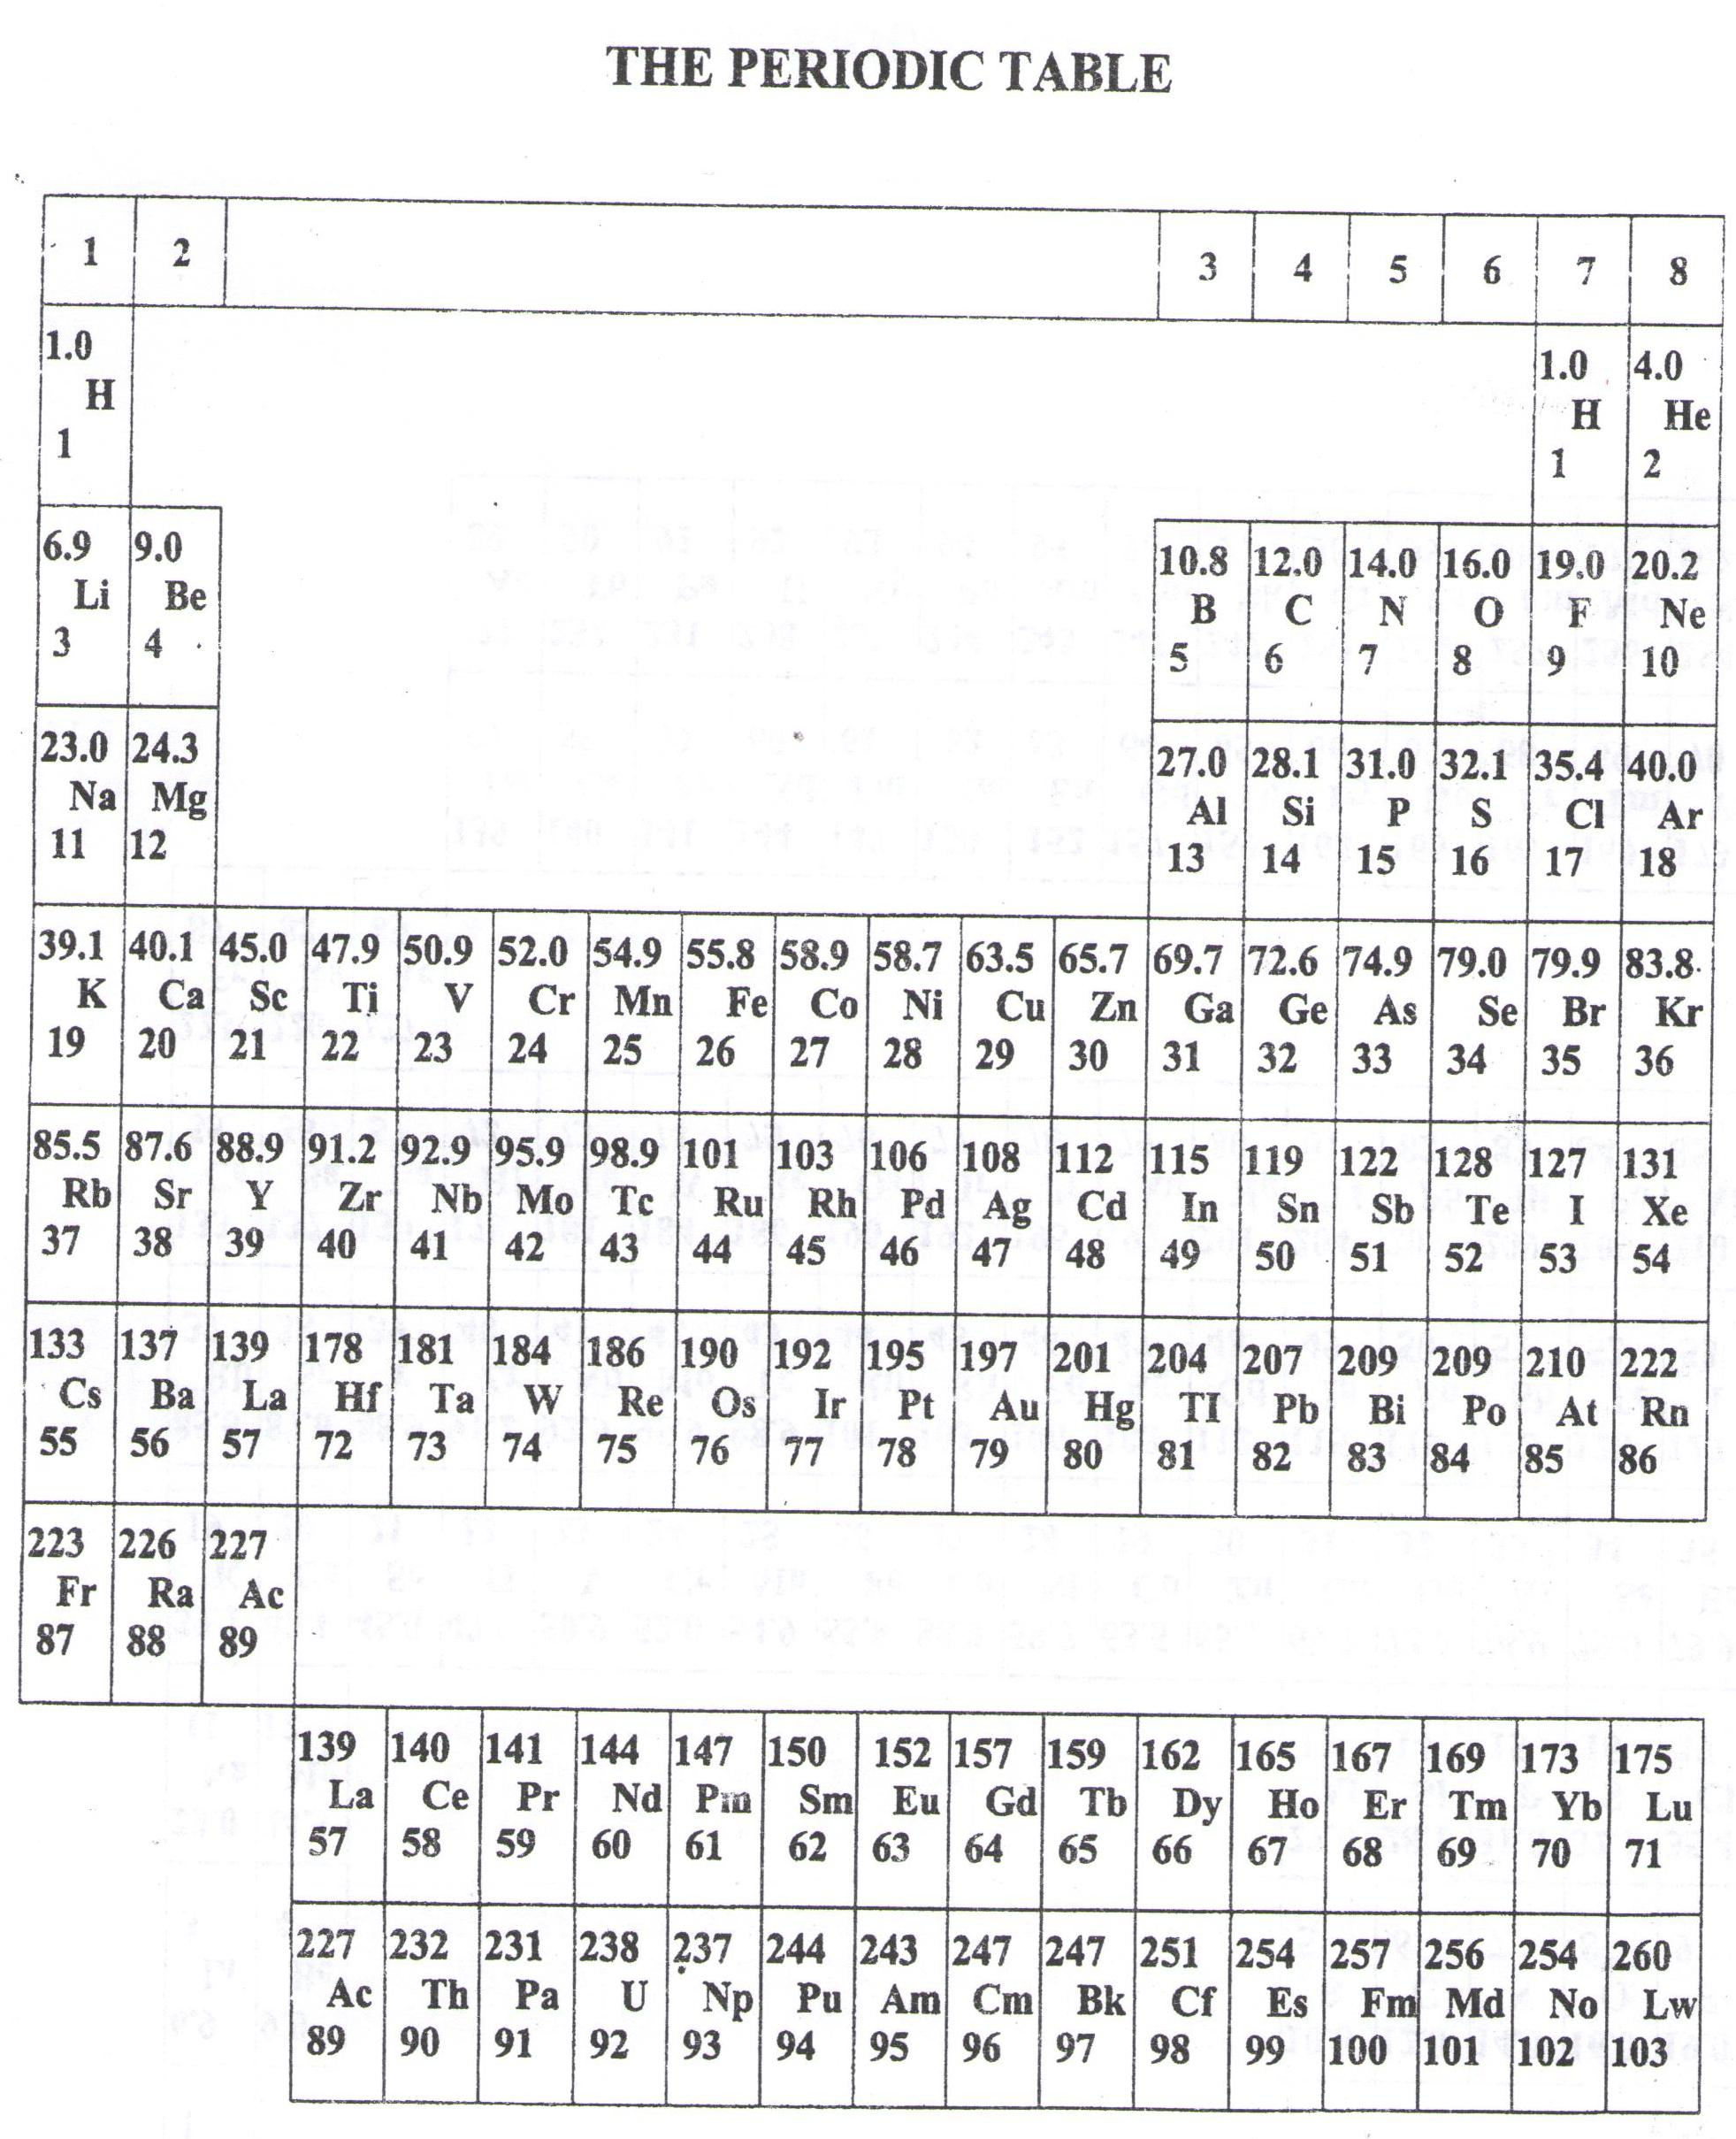

* ===END===

WELCOME TO SENIOR SIX, YEAR 2023

This is the last page of the printed paper, Page 22